Think about all the people in your life who are important to you.

Think about how you met them.


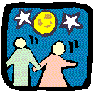
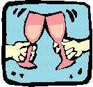

Everyone that is important to us, who are not related to us or are paid to be in our lives. We meet through some form of participation. We need to enable everyone to participate. So their circles of friendship and intimacy are full.

One way to ensure that our children are safe is to maximise the number of people in their lives who care about them, not the number of people paid to support them.

Lynne Elwell

